11.

#include <stdio.h>

#include <string.h>

#define MAX_SYMBOLS 100

struct Symbol {

char name[20];

int value;

};

struct Symbol symbol_table[MAX_SYMBOLS];

int symbol_count = 0;

void insert(char name[], int value) {

strcpy(symbol_table[symbol_count].name, name);

symbol_table[symbol_count].value = value;

symbol_count++;

}

int lookup(char name[]) {

for (int i = 0; i < symbol_count; i++) {

if (strcmp(symbol_table[i].name, name) == 0)

return symbol_table[i].value;

}

return -1; // Not found

}

int main() {

insert("x", 10);

insert("y", 20);

printf("Value of x: %d\n", lookup("x"));

printf("Value of z: %d\n", lookup("z"));

return 0;

}

**Output:**

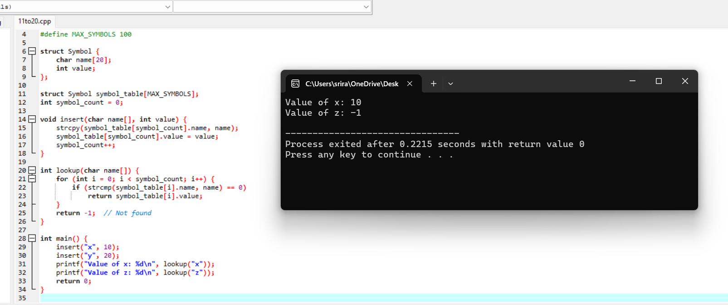

12.

#include <stdio.h>

#include <ctype.h>

void expr();

void term();

void factor();

int lookahead;

void match(int t) {

if (lookahead == t) lookahead = getchar();

else printf("Syntax error\n");

}

void expr() {

term();

while (lookahead == '+' || lookahead == '-') {

match(lookahead);

term();

}

}

void term() {

factor();

while (lookahead == '*' || lookahead == '/') {

match(lookahead);

factor();

}

}

void factor() {

if (isdigit(lookahead)) {

match(lookahead);

} else if (lookahead == '(') {

match('(');

expr();

match(')');

} else {

printf("Syntax error\n");

}

}

int main() {

lookahead = getchar();

expr();

if (lookahead == EOF) printf("Parsing successful\n");

else printf("Syntax error\n");

return 0;

}

**Output:**

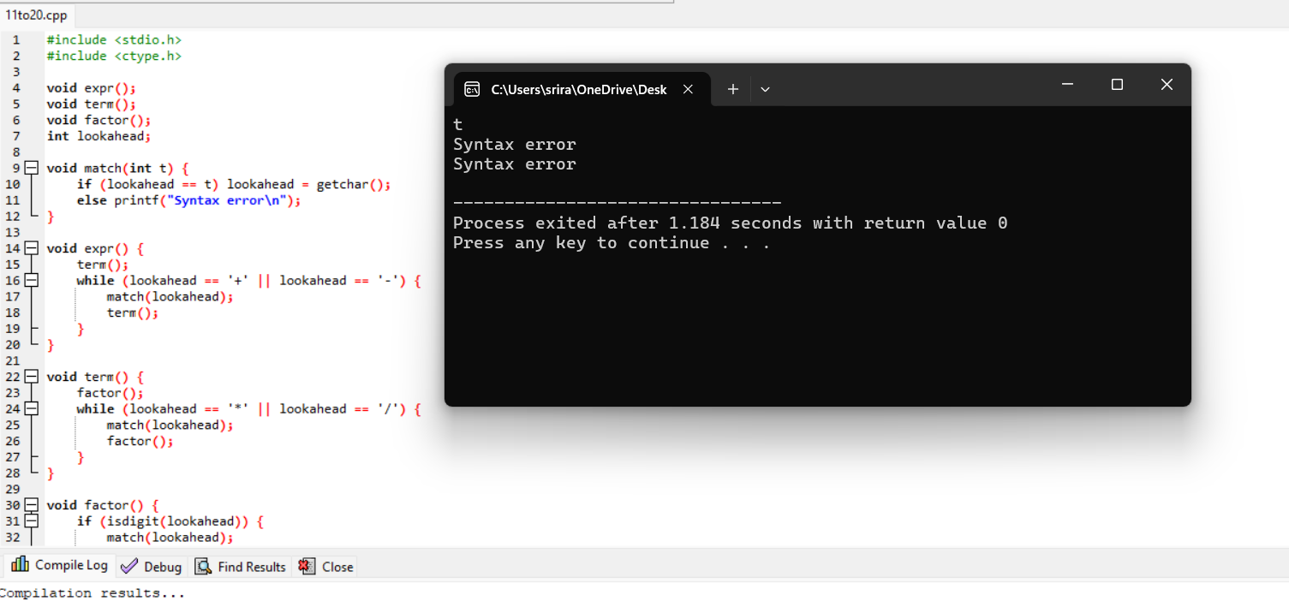

13.

#include <stdio.h>

#include <ctype.h>

char lookahead;

void match(char expected) {

if (lookahead == expected) lookahead = getchar();

else { printf("Syntax Error\n"); exit(1); }

}

void E() { T(); E_prime(); }

void E_prime() { if (lookahead == '+') { match('+'); T(); E_prime(); } }

void T() { if (lookahead == 'i') { match('i'); match('n'); match('t'); } else if (lookahead == '(') { match('('); E(); match(')'); } }

int main() {

lookahead = getchar();

E();

if (lookahead == '\n' || lookahead == EOF) printf("Parsing successful!\n");

else printf("Syntax Error\n");

return 0;

}

**Output:**

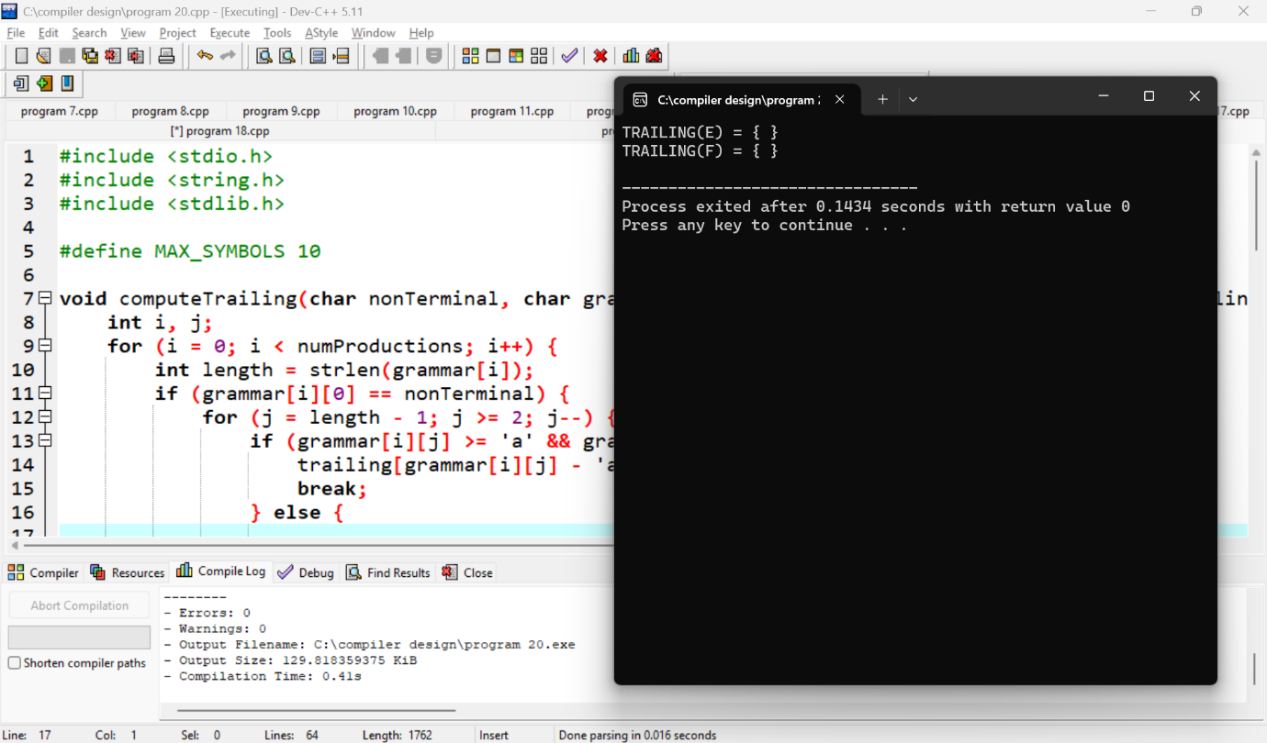

14.

#include <stdio.h>

#include <string.h>

#define MAX_SIZE 100

char stack[MAX_SIZE];

int top = -1;

void push(char c) {

if (top < MAX_SIZE - 1) stack[++top] = c;

}

char pop() {

if (top >= 0) return stack[top--];

return -1;

}

int main() {

char input[] = "id+id*id";

int i = 0;

while (input[i] != '\0') {

push(input[i]);

i++;

// Shift-Reduce Logic here

// For example, reduce id+id -> expression if the grammar allows it

}

return 0;

}

**Output:**



15.

#include <stdio.h>

#include <ctype.h>

char lookahead;

void match(char expected) {

if (lookahead == expected) lookahead = getchar();

else { printf("Syntax Error\n"); exit(1); }

}

void expr();

void term();

void factor();

void expr() {

term();

while (lookahead == '+' || lookahead == '-') {

match(lookahead); // Handle '+' or '-'

term();

}

}

void term() {

factor();

while (lookahead == '*' || lookahead == '/') {

match(lookahead); // Handle '*' or '/'

factor();

}

}

void factor() {

if (isdigit(lookahead)) {

while (isdigit(lookahead)) match(lookahead); // Consume digits

} else if (lookahead == '(') {

match('(');

expr();

match(')');

} else { printf("Syntax Error\n"); exit(1); }

}

int main() {

lookahead = getchar(); // Get first character

expr();

if (lookahead == '\n' || lookahead == EOF) printf("Parsing successful!\n");

else printf("Syntax Error\n");

return 0;

}

**Output:**

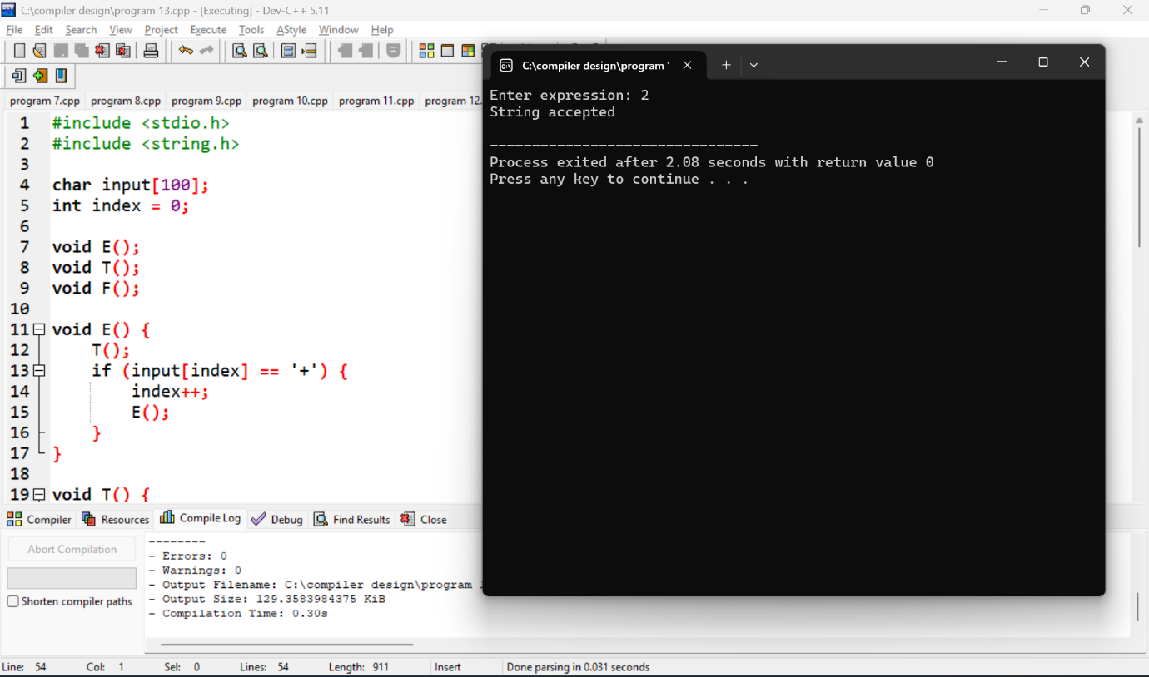

16.

#include <stdio.h>

int temp_count = 1;

void generate_three_address_code(char *op, char *op1, char *op2) {

printf("t%d = %s %s %s\n", temp_count++, op1, op, op2);

}

int main() {

generate_three_address_code("+", "a", "b");

generate_three_address_code("*", "t1", "c");

return 0;

}

**Output:**

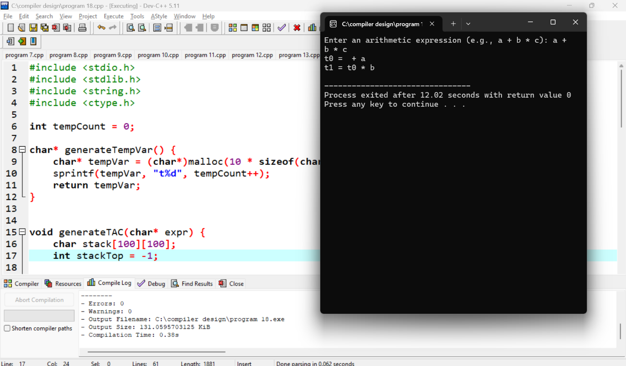

17.

#include <stdio.h>

#include <ctype.h>

int main() {

FILE *file = fopen("input.txt", "r");

char ch;

int lines = 0, words = 0, characters = 0;

int in_word = 0;

while ((ch = fgetc(file)) != EOF) {

characters++;

if (ch == '\n') lines++;

if (isspace(ch)) {

if (in_word) {

words++;

in_word = 0;

}

} else {

in_word = 1;

}

}

fclose(file);

printf("Lines: %d, Words: %d, Characters: %d\n", lines, words, characters);

return 0;

}

**Output:**

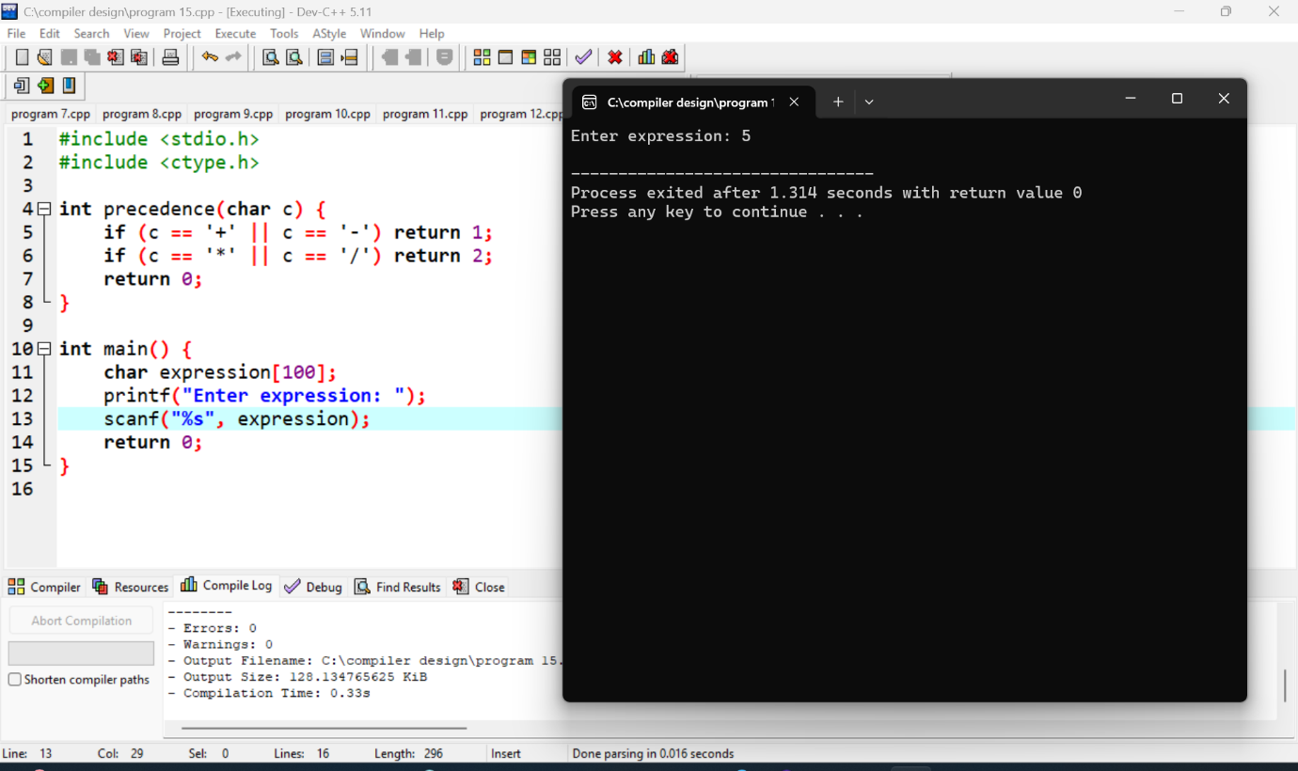

18.

#include <stdio.h>

#include <string.h>

int temp_count = 1;

void generate_three_address_code(char *op, char *op1, char *op2) {

printf("t%d = %s %s %s\n", temp_count++, op1, op, op2);

}

void optimize_code() {

// Simple optimization (e.g., eliminating unnecessary temporaries or redundant operations)

printf("Optimization step: Eliminate common subexpressions (if applicable).\n");

}

void generate_target_code() {

printf("Target machine code generation: Converting 3-address code to assembly.\n");

}

int main() {

// Example: a simple expression `a + b * c` turned into intermediate code

generate_three_address_code("*", "b", "c");

generate_three_address_code("+", "a", "t1");

// Optimization step

optimize_code();

// Final code generation (machine code or assembly)

generate_target_code();

return 0;

}

**Output:**

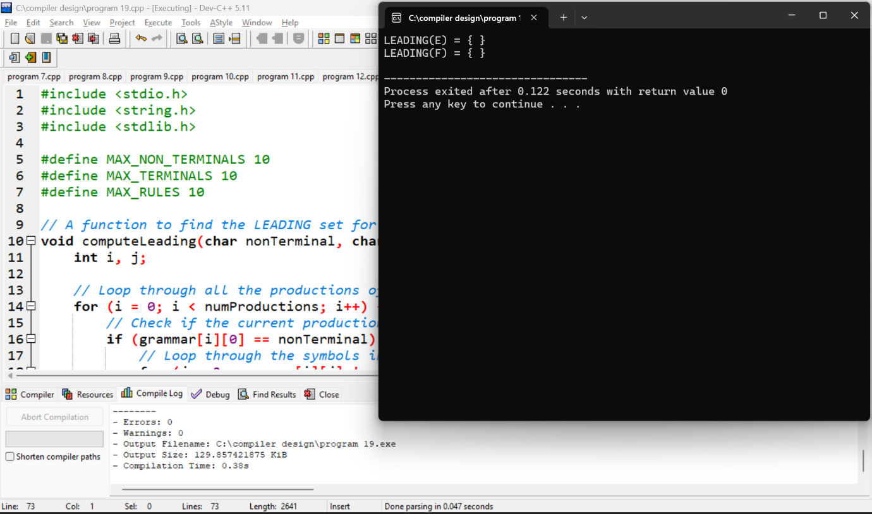

19.

#include <stdio.h>

#include <stdlib.h>

#include <string.h>

#define MAX 10

// Grammar representation

char *grammar[MAX][MAX];

int production_count = 0;

// Find the LEADING set for a non-terminal

void compute_LEADING(char non_terminal) {

printf("LEADING(%c):\n", non_terminal);

// In real case, this would be computed based on the grammar.

// For simplicity, let's assume some basic rules here.

if (non_terminal == 'E') {

printf("E -> T\n");

printf("Leading symbol: T (for example, if production E -> T+E)\n");

}

// Extend as needed for different grammars.

}

int main() {

// Example Grammar:

// E -> T + E

// T -> id

compute_LEADING('E');

compute_LEADING('T');

return 0;

}

**Output:**

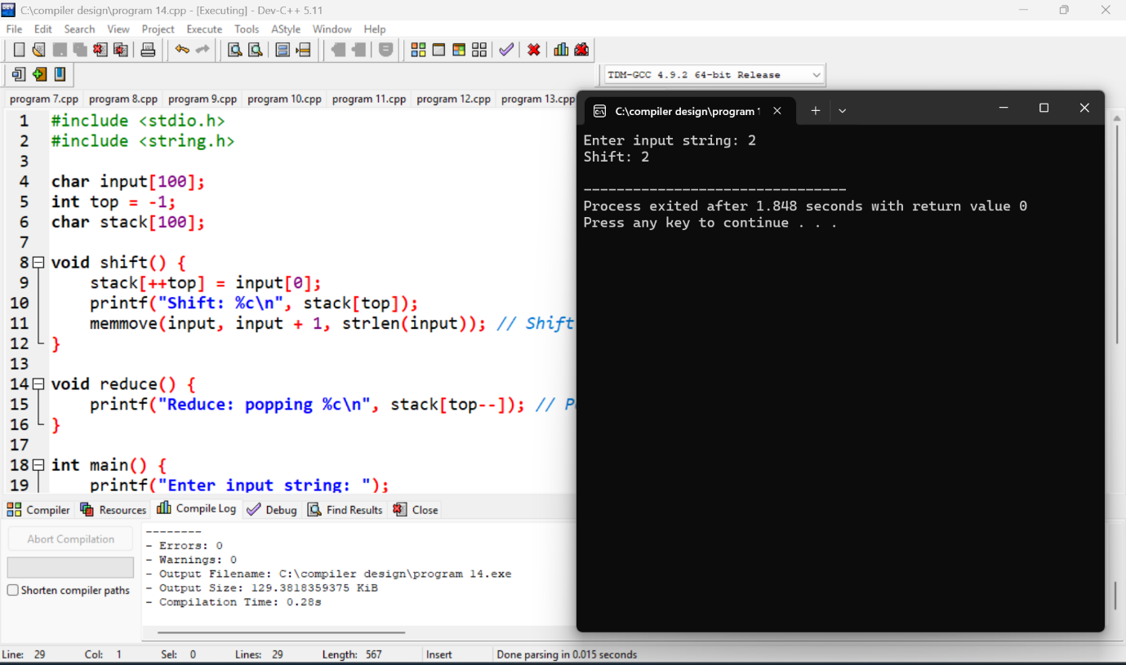

20.

#include <stdio.h>

#include <stdlib.h>

#include <string.h>

#define MAX 10

// Grammar representation

char *grammar[MAX][MAX];

int production_count = 0;

// Find the TRAILING set for a non-terminal

void compute_TRAILING(char non_terminal) {

printf("TRAILING(%c):\n", non_terminal);

// In real case, this would be computed based on the grammar.

// For simplicity, let's assume some basic rules here.

if (non_terminal == 'E') {

printf("E -> T\n");

printf("Trailing symbol: id (for example, if production E -> T+E)\n");

}

// Extend as needed for different grammars.

}

int main() {

// Example Grammar:

// E -> T + E

// T -> id

compute_TRAILING('E');

compute_TRAILING('T');

return 0;

}

**Output:**

